Source Code for the 3 solenoid simulation: (the other simulations have similar sources, the only difference is the parametric equation used to define the coils

Nfilament = 0;

figure(1), hold on, grid on, box on, axis equal

xlabel('x [m]'), ylabel('y [m]'), zlabel('z [m]')

view(3), axis tight

theta = linspace(-10*pi,10*pi,2*100);

zzzz=linspace(-.01, .01, 2*100);

xln=cos(theta')*.131/2;

yln=zzzz';

zln=sin(theta')*.131/2;

ctt = cos(-30/180*pi);

stt = sin(-30/180*pi);

xlol = xln*ctt + yln*(-stt);

ylol = xln*stt + yln*ctt;

zlol = zln;

Gamma = [xlol+.414,ylol+.224,zlol+.205]; % x,y,z [m,m,m]

I = 0.42*32; % filament current [A]

dGamma = 1e9; % filament max discretization step [m

n = Nfilament+1;

filament(n).Gamma = Gamma;

filament(n).I = I;

filament(n).dGamma = dGamma;

Nfilament = n;

theta2 = linspace(-10*pi,10*pi,2*100);

xx=zzzz';

yy=cos(theta2')*.131/2;

zz=sin(theta2')*.131/2;

%ROTATION 1

cfk = cos(40.2/180*pi);

sfk = sin(40.2/180*pi);

xxfk = xx*cfk + zz*sfk;

yyfk = yy;

zzfk = xx*(-sfk) + zz*(cfk);

%ROTATION 2

cc = cos(-22.1/180*pi);

ss = sin(-22.1/180*pi);

xxn = xxfk*cc+yyfk*(-ss);

yyn = xxfk*ss + yyfk*(cc);

zzn = zzfk;

Gamma2 = [xxn+.40, yyn+0.38, zzn+.25]; % x,y,z [m,m,m]

I2 = -0.61*32; % filament current [A]

dGamma2 = 1e9; % filament max discretization step [m]

n = Nfilament+1;

filament(n).Gamma = Gamma2;

filament(n).I = I;

filament(n).dGamma = dGamma2;

Nfilament = n;

theta3 = linspace(-10*pi,10*pi,2*100);

xx3=linspace(-.03, .03, 2*100)';

yy3=cos(theta3')*.054/2;

zz3=sin(theta3')*.054/2;

cc3 = cos(101.1/180*pi);

ss3 = sin(101.1/180*pi);

lol3=[xx3, yy3, zz3];

xxn3 = xx3*cc3+yy3*(-ss3);

yyn3 = xx3*ss3 + yy3*(cc3);

zzn3 = zz3;

idk3=[xxn3, yyn3, zzn3];

cfk3 = cos(-88.2/180*pi);

sfk3 = sin(-88.2/180*pi);

xxfk3 = xxn3;

yyfk3 = yyn3*cfk3 + zzn3*(-sfk3);

zzfk3 = yyn3*sfk3 + zzn3*(cfk3);

Gamma3 = [xxfk3+.48, yyfk3+0.36, zzfk+.22]; % x,y,z [m,m,m]

I3 = 1.2*120; % filament current [A]

dGamma3 = 1e9; % filament max discretization step [m]

n = Nfilament+1;

filament(n).Gamma = Gamma3;

filament(n).I = I3;

filament(n).dGamma = dGamma3;

Nfilament = n;

% MAKE MESH

x_M = linspace(.15,.8,41); % x [m]

y_M = linspace(.05,.6,41); % y [m]

z_M = linspace(-.15,.40,41); % z [m]

[X_M,Y_M,Z_M]=meshgrid(x_M,y_M,z_M);

mu0 = 4*pi*1e-7; % vacuum permeability [N/A^2]

BX = zeros(size(X,1),size(X,2),size(X,3));

BY = zeros(size(X,1),size(X,2),size(X,3));

BZ = zeros(size(X,1),size(X,2),size(X,3));

for nF = 1:Nfilament % Loop on each filament

Gamma = filament(nF).Gamma;

dGamma =filament(nF).dGamma;

I = filament(nF).I;

% Discretization of Gamma

x_P = []; y_P = []; z_P = [];

N = size(Gamma,1)-1; % Number of points defining Gamma

for i = 1:N % Loop on the segments defining gamma

L_Gamma_i = norm(Gamma(i,:)-Gamma(i+1,:));

NP = ceil(L_Gamma_i/dGamma); % Number of points required to have a discretization step smaller than dGamma

x_P = [x_P,linspace(Gamma(i,1), Gamma(i+1,1), NP)]; % discretization of Gamma for x component

y_P = [y_P,linspace(Gamma(i,2), Gamma(i+1,2), NP)]; % discretization of Gamma for y component

z_P = [z_P,linspace(Gamma(i,3), Gamma(i+1,3), NP)]; % discretization of Gamma for z component

end

% Add contribution of each source point P on each field point M (where we want to calculate the field)

for m = 1:size(X,1);

for n = 1:size(X,2);

for p = 1:size(X,3);

% M is the field point

x_M = X(m,n,p);

y_M = Y(m,n,p);

z_M = Z(m,n,p);

% Loop on each discretized segment of Gamma PkPk+1

for k = 1:length(x_P)-1

PkM3 = (sqrt((x_M-x_P(k))^2 + (y_M-y_P(k))^2 + (z_M-z_P(k))^2))^3;

DBx(k) = ((y_P(k+1)-y_P(k))*(z_M-z_P(k))-(z_P(k+1)-z_P(k))*(y_M-y_P(k)))/PkM3;

DBy(k) = ((z_P(k+1)-z_P(k))*(x_M-x_P(k))-(x_P(k+1)-x_P(k))*(z_M-z_P(k)))/PkM3;

DBz(k) = ((x_P(k+1)-x_P(k))*(y_M-y_P(k))-(y_P(k+1)-y_P(k))*(x_M-x_P(k)))/PkM3;

end

% Sum

BX(m,n,p) = BX(m,n,p) + mu0*I/4/pi*sum(DBx);

BY(m,n,p) = BY(m,n,p) + mu0*I/4/pi*sum(DBy);

BZ(m,n,p) = BZ(m,n,p) + mu0*I/4/pi*sum(DBz);

end

end

end

end

%x_M = linspace(.15,.8,41); % x [m]

%y_M = linspace(.05,.6,41); % y [m]

%z_M = linspace(-.15,.40,41); % z [m]

% Plot Bz on the volume

%disp([y_M(13)," ", z_M(28)]);

%disp(x_M(:));

%disp(BX(13,:,28)'*1e3);

disp(x_M(23));

disp(y_M(17));

disp(z_M(29));

BX(21:1:25, 15:1:19, 27:1:31)=0.01*BX(21:1:25, 15:1:19, 27:1:31);

BY(21:1:25, 15:1:19, 27:1:31)=0.001*BY(21:1:25, 15:1:19, 27:1:31);

BZ(21:1:25, 15:1:19, 27:1:31)=10*BZ(21:1:25, 15:1:19, 27:1:31);

disp(BX(23, 17, 29));

disp(BY(23, 17, 29));

disp(BZ(23, 17, 29));

figure(2), hold on, box on, grid on

plot3(Gamma(:,1),Gamma(:,2),Gamma(:,3),'.-r') % coil 1

plot3(Gamma2(:,1),Gamma2(:,2),Gamma2(:,3),'.-g') % coil 2

plot3(Gamma3(:,1),Gamma3(:,2),Gamma3(:,3),'.-b') % 3

slice(X,Y,Z,BX,[],[],[.24125]), colorbar % B

xlabel ('x [m]'), ylabel ('y [m]'), zlabel ('z [m]'), title ('BX [T]')

view(3), axis equal, axis tight

caxis([-30,30]*1e-4)

figure(3), hold on, box on, grid on

plot3(Gamma(:,1),Gamma(:,2),Gamma(:,3),'.-r') % coil 1

plot3(Gamma2(:,1),Gamma2(:,2),Gamma2(:,3),'.-g') % coil 2

plot3(Gamma3(:,1),Gamma3(:,2),Gamma3(:,3),'.-b') % 3

slice(X,Y,Z,BY,[],[.215],[.24125]), colorbar % B

xlabel ('x [m]'), ylabel ('y [m]'), zlabel ('z [m]'), title ('BY [T]')

view(3), axis equal, axis tight

caxis([-30,30]*1e-4)

figure(4), hold on, box on, grid on

plot3(Gamma(:,1),Gamma(:,2),Gamma(:,3),'.-r') % coil 1

plot3(Gamma2(:,1),Gamma2(:,2),Gamma2(:,3),'.-g') % coil 2

plot3(Gamma3(:,1),Gamma3(:,2),Gamma3(:,3),'.-b') % 3

slice(X,Y,Z,BZ,[],[.215],[.24125]), colorbar % B

xlabel ('x [m]'), ylabel ('y [m]'), zlabel ('z [m]'), title ('BZ [T]')

view(3), axis equal, axis tight

caxis([-30,30]*1e-4)

% Plot some flux tubes

figure(5), hold on, box on, grid on

plot3(Gamma(:,1),Gamma(:,2),Gamma(:,3),'.-k') % 1

plot3(Gamma2(:,1),Gamma2(:,2),Gamma2(:,3),'.-k') % 2

plot3(Gamma3(:,1),Gamma3(:,2),Gamma3(:,3),'.-k') % 2

% plot3(lol(:,1),lol(:,2),lol(:,3),'.-y') % test

% plot3(idk(:,1),idk(:,2),idk(:,3),'.-b') % test

[X0,Y0,Z0] = ndgrid(.38:.06:.62, ...

.15:.06:.39, ...

0.2); % tubes starting point

htubes = streamtube(stream3(X,Y,Z,BX,BY,BZ,X0,Y0,Z0), [0.1 2]);

xlabel ('x (m)'), ylabel ('y (m)'), zlabel ('z (m)'), title ('')

view(3), axis equal, axis tight

set(htubes,'EdgeColor','none','FaceColor',[0.83 0.83 0.83]) % change tube color

camlight left % change tube light

Pics:

Theoretical B fields in all components for 2 solenoids:

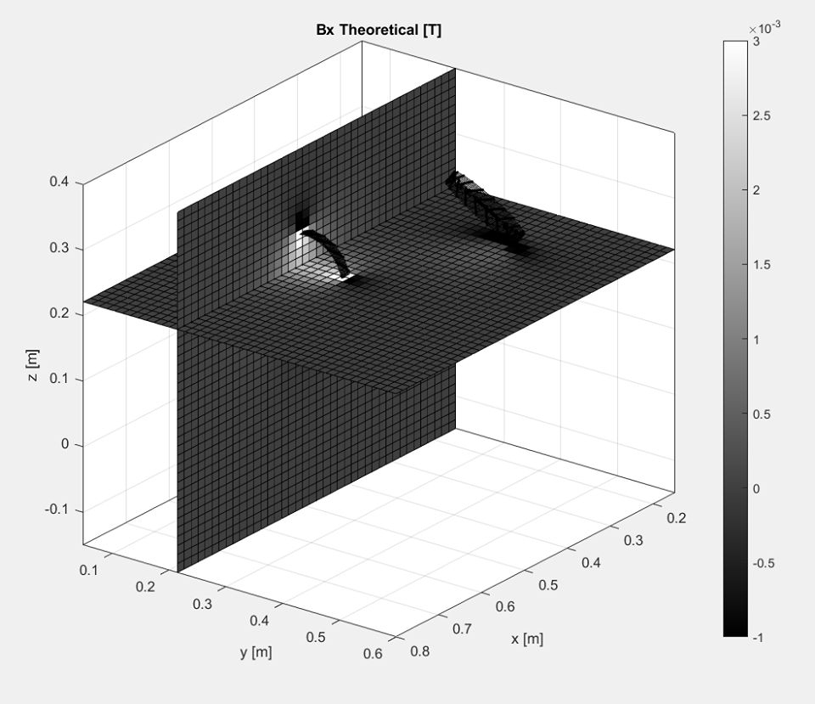 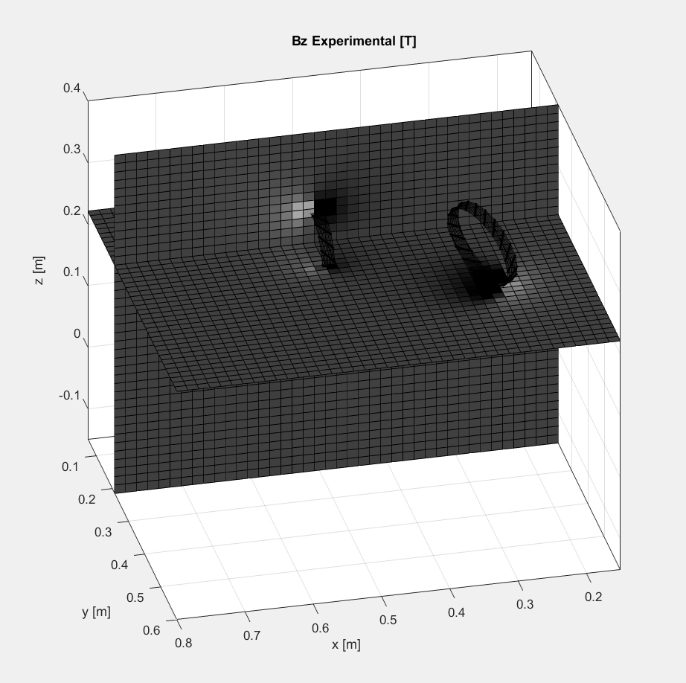

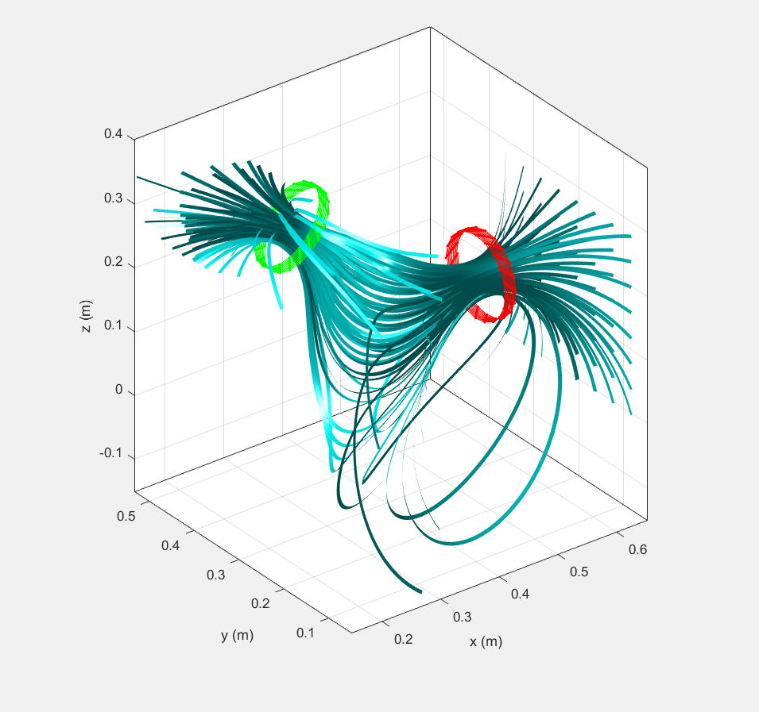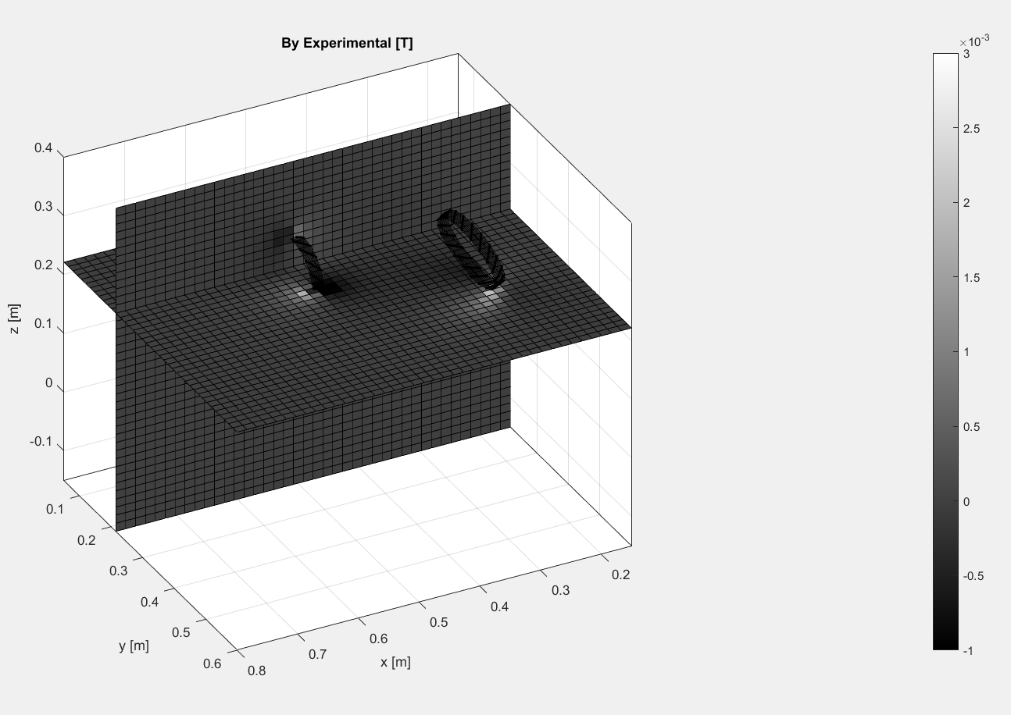

B Field for 3 solenoids

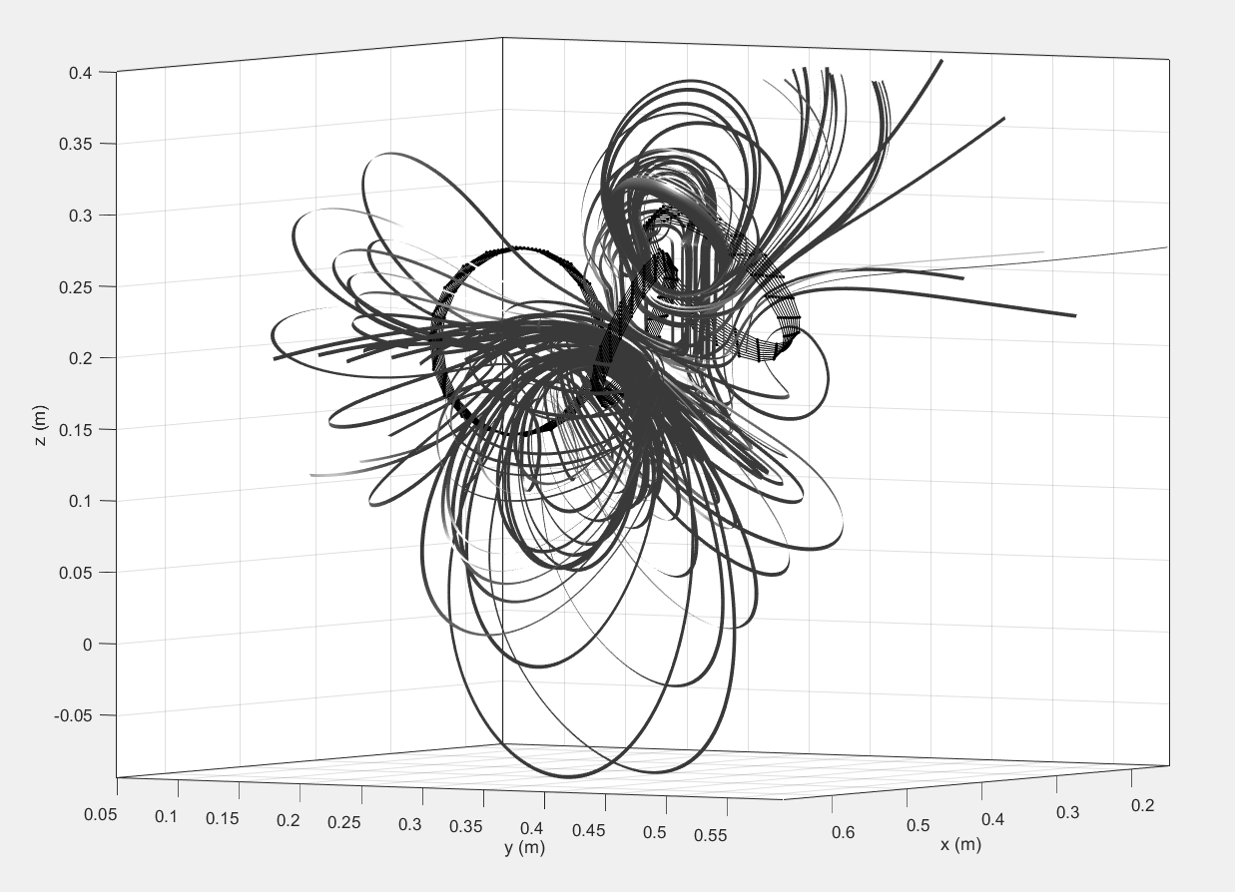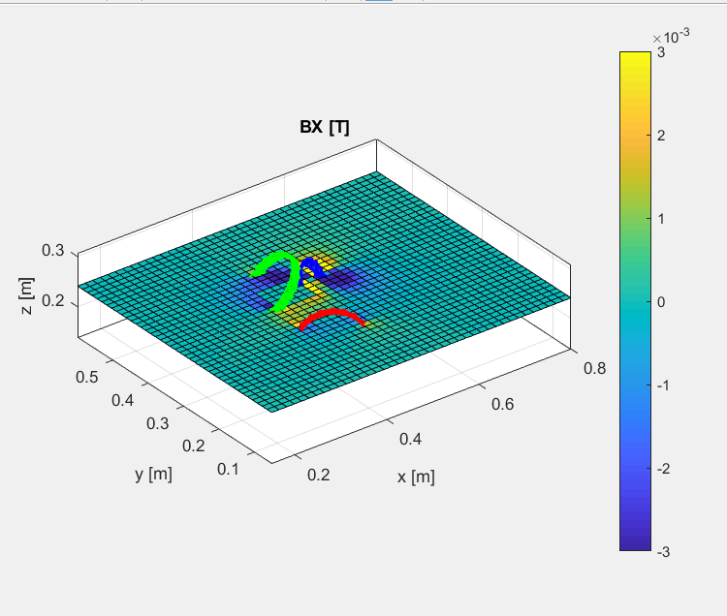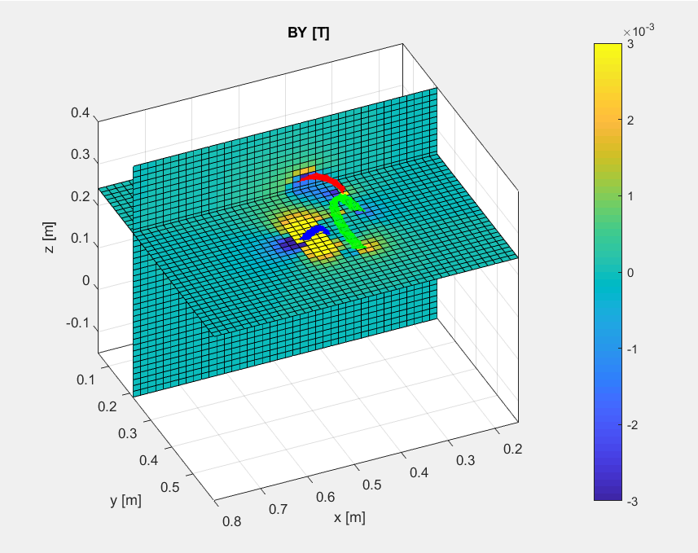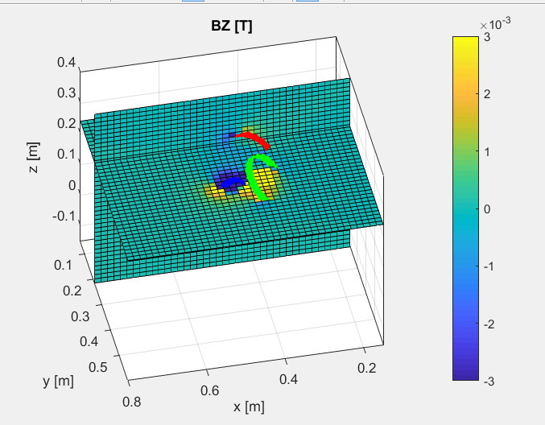

2 Heimholtz parallel

